**6. IMPLEMENT PROGRAM TO APPLY MOVING AVERAGE SMOOTHING FOR DATA PREPARATION AND TIME SERIES FORECASTING.**

**AIM:**

Implement program to apply moving average smoothing for data preparation and time series forecasting.

**PROCEDURE:**

1. **Import The Necessary Libraries :**

import numpy as np

import pandas as pd

import matplotlib.pyplot as plt

# Generate sample petrol price data (for demonstration)

np.random.seed(42)

dates = pd.date_range(start="2024-01-01", periods=100, freq="D")

prices = np.cumsum(np.random.randn(100)) + 100 # Simulated petrol prices

1. **Load the dataset :**

df = pd.DataFrame({"Date": dates, "Price": prices})

df.set_index("Date", inplace=True)

1. **Ensure relevant columns exist :**

def moving_average(series, window):

return series.rolling(window=window).mean()

**4.** **Apply Moving Average Smoothing :**

window_size = 7 # Weekly moving average

df["Smoothed"] = moving_average(df["Price"], window_size)

**5.** **Forecast using Moving Average**

future_steps = 10

future_dates = pd.date_range(start=df.index[-1] + pd.Timedelta(days=1), periods=future_steps, freq="D")

future_prices = [df["Smoothed"].iloc[-window_size:].mean()] * future_steps

**6. Plotting The Result**:

plt.figure(figsize=(10, 5))

plt.plot(df.index, df["Price"], label="Original Prices", linestyle="dashed", alpha=0.6)

plt.plot(df.index, df["Smoothed"], label="Smoothed Prices", linewidth=2)

plt.plot(future_dates, future_prices, label="Forecasted Prices", linestyle="dotted", marker="o")

plt.xlabel("Date")

plt.ylabel("Petrol Price")

plt.legend()

plt.title("Moving Average Smoothing & Forecasting for Petrol Prices")

plt.show()

**OUTPUT :**

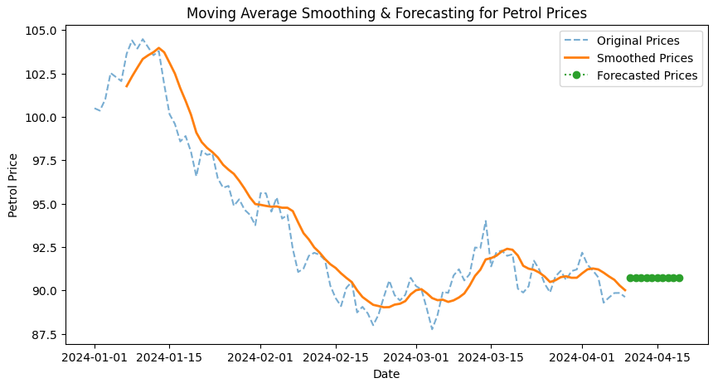

**RESULT:**

The program to implement to apply moving average smoothing on the autism screening dataset has been implemented successfully.